Super Sopper (Dolphin)
Instructions

To use:
Push down on the black tension roller and hand tight the tension nut down on both sides
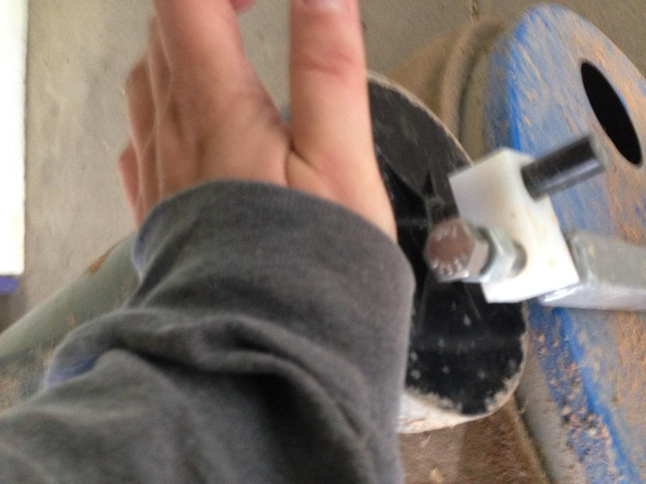

Push the roller over the area to absorb water. Once you see water come to the top of the elbow pipe on the right side. Take the unit to an area off of the field to drain. You can either turn the elbow piece down to drain or remove the cap from the left side.
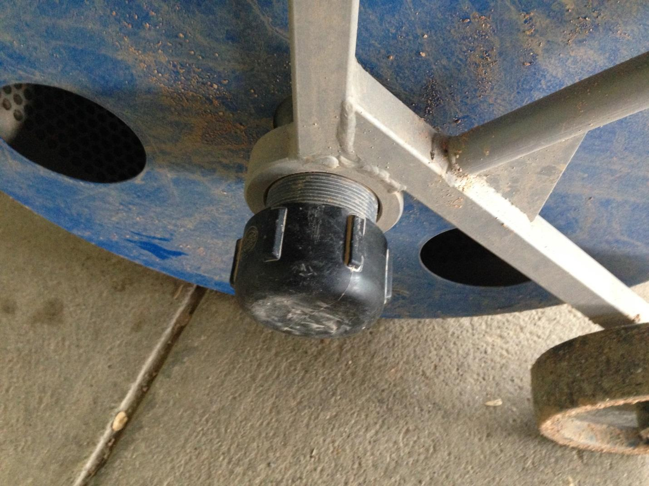

To store unit:
Release the tension roller by pushing down on it and wind the tension nut back out like so
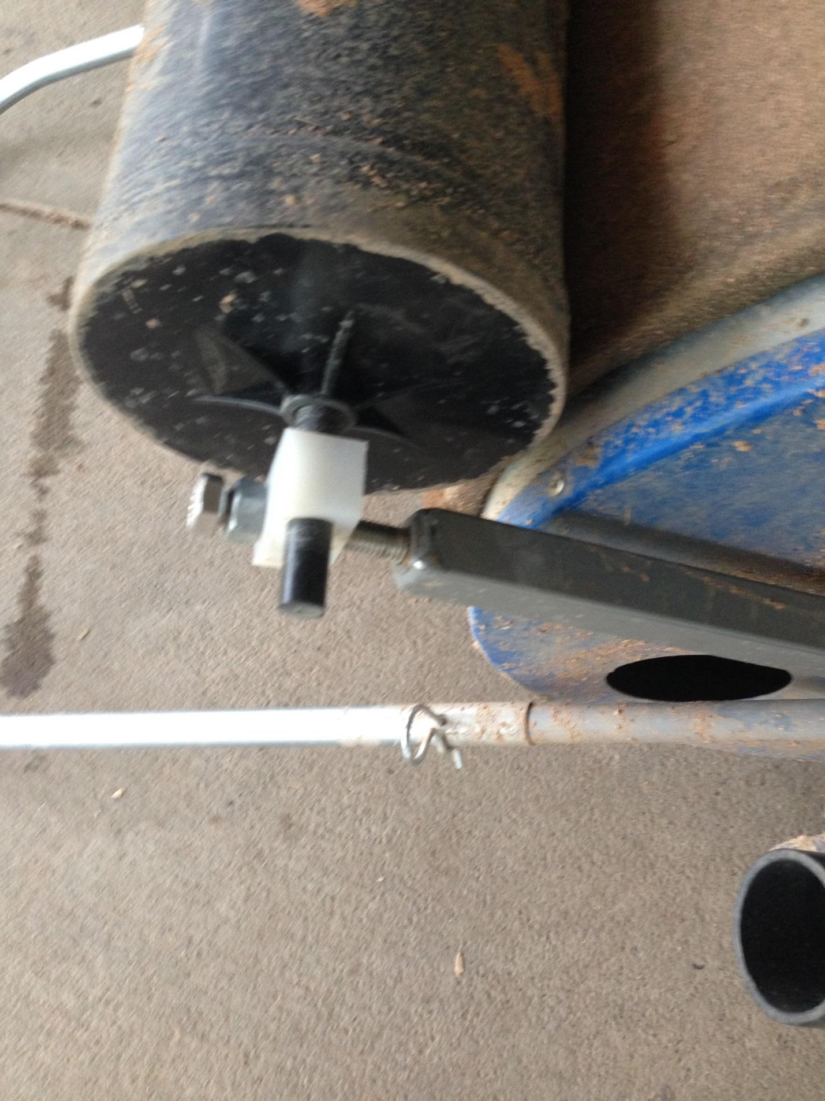
Once you release the tension nut, flip the handle down onto the ground to have the roller elevated from the ground like so:
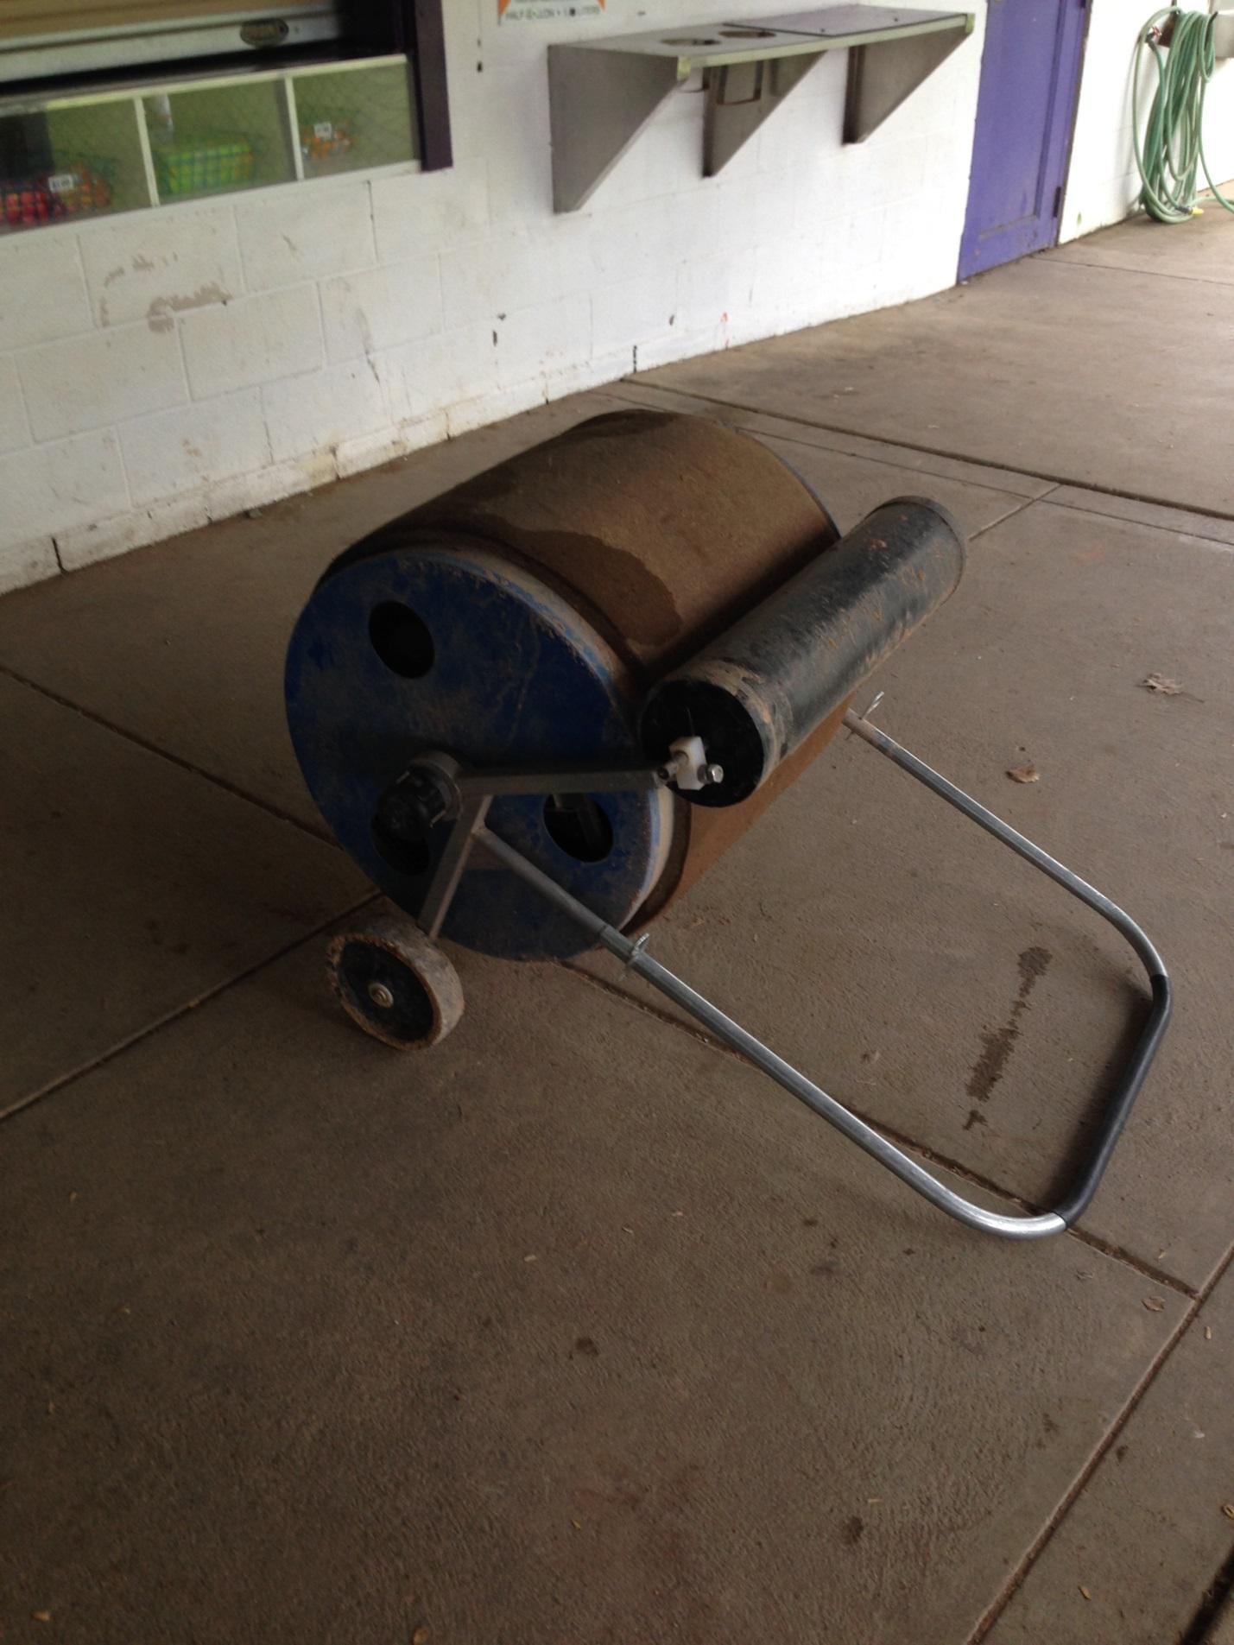
Releasing the tension roller will keep it from getting a permenant indent in the sponge. Also elevating the roller will allow the whole unit to dry out and so the sponge doesn’t get a flat side on it.

